

**Instituto Tecnológico de Estudios Superiores Monterrey**

**CAMPUS QUERÉTARO**

**Construcción de software y toma de decisiones**

Ricardo Cortés Espinosa

Grupo 402

**Interfaz y Prototipo**



**PRESENTAN**

| Daniel Felipe Hurtado Giraldo | A01707774 |
| --- | --- |
| Jose Armando Rosas Balderas | A01704132 |
| Sebastian Armando Flores Lemus | A01709229 |
| Rodrigo Terán Hernández | A01704108 |
| Ramona Nájera Fuentes | A01423596 |

Fecha:

12/03/2023

**Vista cliente mobile:**

<https://www.figma.com/proto/xoPPxUWUNoCgwLlaWdrMok/ui2?node-id=224%3A8616&scaling=scale-down&page-id=0%3A1&starting-point-node-id=224%3A8616&show-proto-sidebar=1>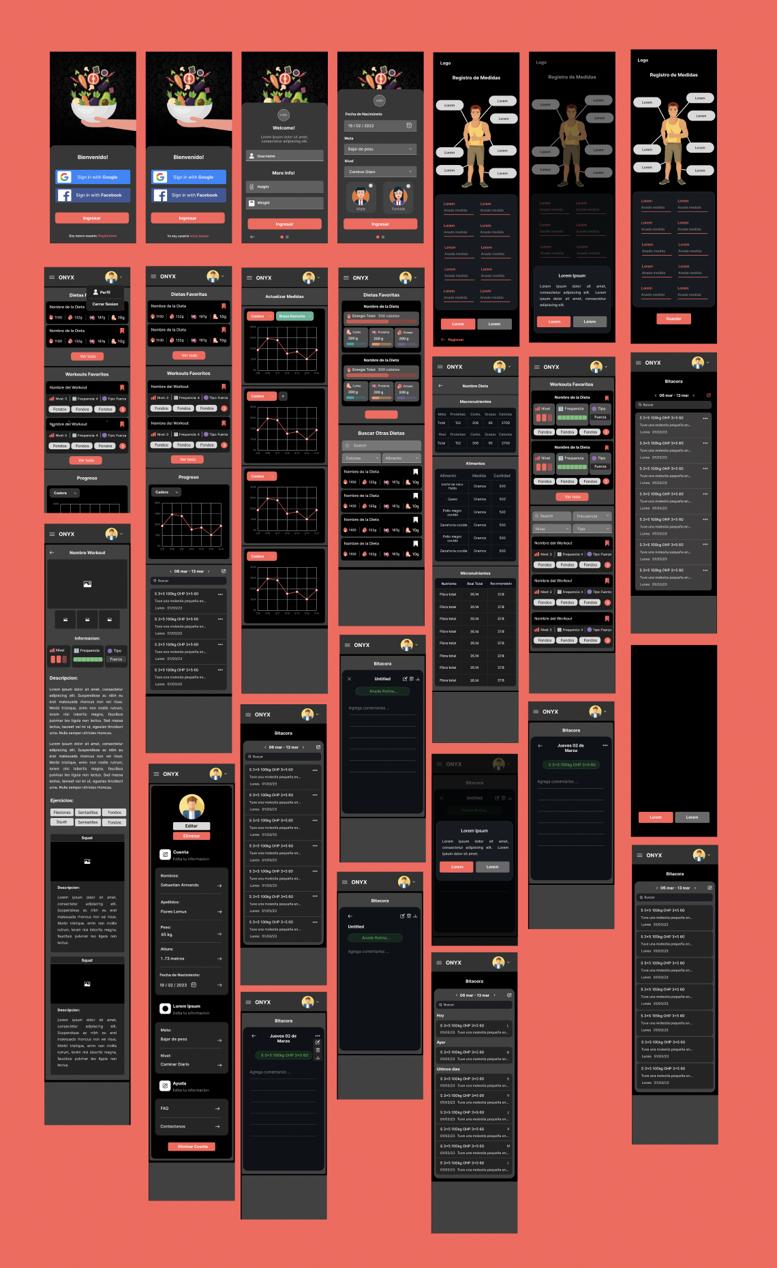

**Desktop cliente:** <https://www.figma.com/proto/xoPPxUWUNoCgwLlaWdrMok/ui2?node-id=254%3A5241&scaling=scale-down&page-id=254%3A5240&starting-point-node-id=254%3A5241>

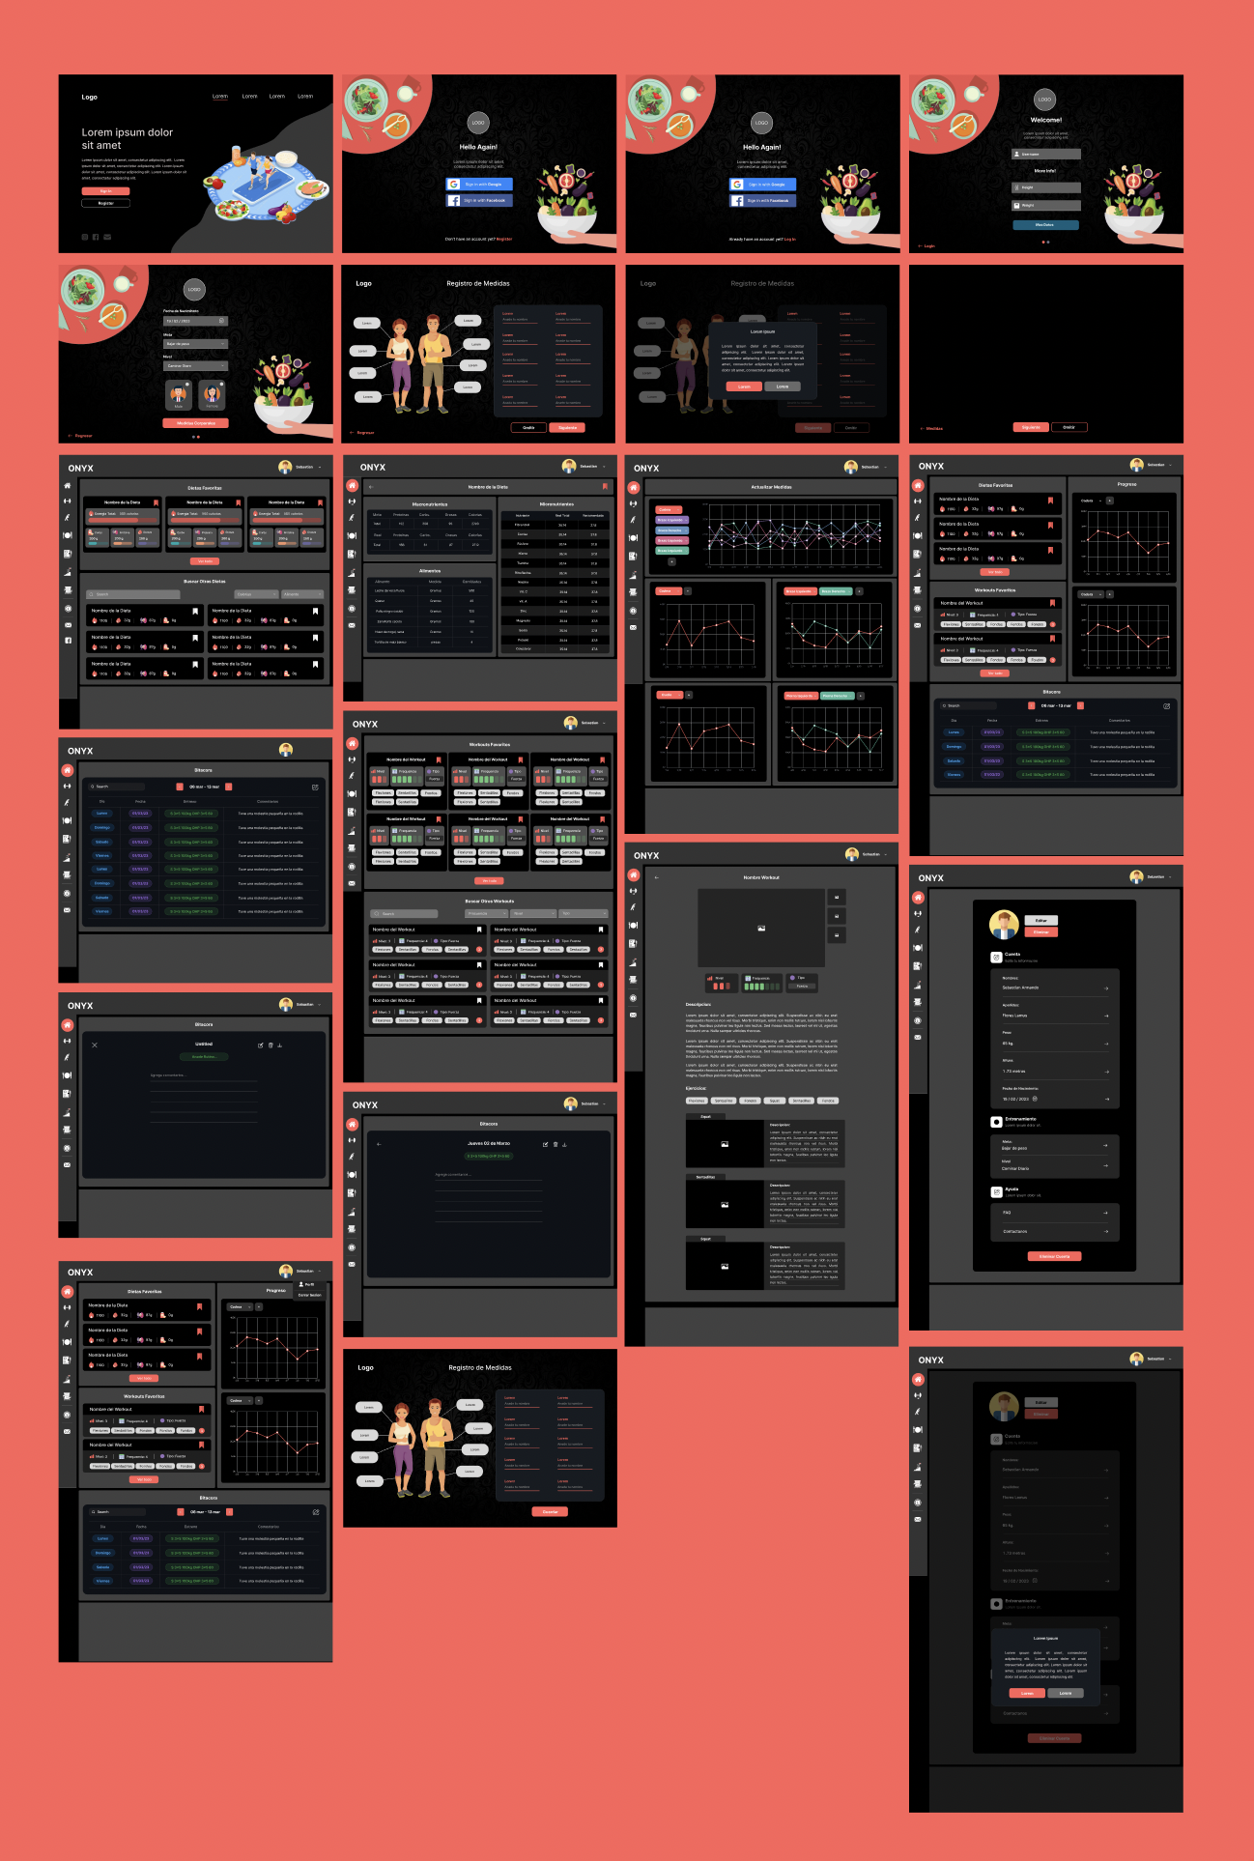

**Vista admin desktop:** <https://www.figma.com/proto/xoPPxUWUNoCgwLlaWdrMok/ui2?node-id=273%3A15150&scaling=scale-down&page-id=254%3A8855&starting-point-node-id=273%3A14711>

